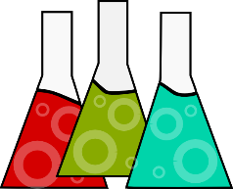
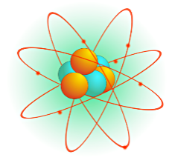
Science
Retest Request

Name_______________________________________________
Topic for retest:

Date requested for retest
______________________________

Date _______________________________________________
College____________________________________________
Reflect
Previous Grade ________
Why did you earn this grade?
____________________________________________________________________________________________________________________________________________________________________________________________________________________________________________

- Vocabulary extra work
- Class Notes (color)
- Activity (Foldable)
- Topic Question answered
- Lab Notes
- Formal Lab report
- Science Literacy or literacy retake

Three Things You did to improve your understanding of
the concept(s):
1. Workbook Pages
2. Sections Reviews – Textbook!
3. Chapter Review – Textbook!
4. TCAP review – Textbook!
5. Math practice when applicable

Attach
- Previous Test or Quiz
- Proof of the three activities you completed to improve your understanding

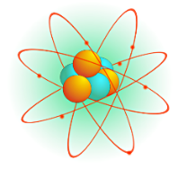
Science
Retest Request

Retest Request
Topic for retest:

Date requested for retest
______________________________

Name_______________________________________________
Date _______________________________________________
College____________________________________________
Reflect
Previous Grade ________
Why did you earn this grade?
____________________________________________________________________________________________________________________________________________________________________________________________________________________________________________

- Vocabulary extra work
- Class Notes (color)
- Activity (Foldable)
- Topic Question answered
- Lab Notes
- Formal Lab report
- Science Literacy or literacy retake

Three Things You did to improve your understanding of
the concept(s):

1. Workbook Pages
2. Sections Reviews – Textbook!
3. Chapter Review – Textbook!
4. TCAP review – Textbook!
5. Math practice when applicable

Attach
- Previous Test or Quiz
- Proof of the three activities you completed to improve your understanding

